Entity-Relationship Diagram of

Prophet Muhammad's ﷺ Family

# **Example #01 | Using Self Join :**

## **SQL Query :**

Method One:

-- Self join by INNER JOIN

SELECT a.Id, a.Name AS 'Name', b.Name AS 'Parent Name' FROM Family a

INNER JOIN Family b ON a.ParentName = b.Id;

Method Two:

-- Self join by WHERE clause

SELECT a.Name AS 'Name', b.Name AS 'Parent Name' FROM Family a, Family b WHERE a.ParentName = b.Id;

**Output­­­**

**Raw Data**

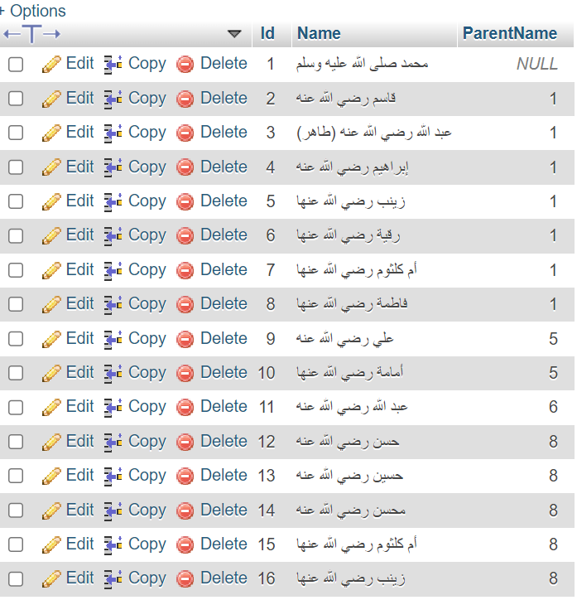

**Using Self Join Data**

